**Task 4**



$$X\sim N\left(0,1\right): PDF_{X}\left(x\right)=\frac{1}{\sqrt{2π}}e^{- \frac{x^{2}}{2}}$$

$$Y\sim N\left(0,1\right): PDF_{Y}\left(y\right)=\frac{1}{\sqrt{2π}}e^{- \frac{y^{2}}{2}}$$

* As $X$ and $Y$ are independent $PDF_{X,Y}\left(x,y\right)=PDF_{X}\left(x\right)⋅PDF_{Y}\left(y\right)$.

$$PDF_{X,Y}\left(x,y\right)=\frac{1}{\sqrt{2π}}e^{- \frac{x^{2}}{2}}⋅\frac{1}{\sqrt{2π}}e^{- \frac{y^{2}}{2}}=\frac{e^{-(x^{2}+y^{2})/2}}{2π}$$

So joint PDF for $X$ and $Y$ is

$$PDF_{X,Y}\left(x,y\right)=\frac{e^{-(x^{2}+y^{2})/2}}{2π}$$

* Next, we can draw its level curves. For that we need to draw graphs of $PDF(x, y)=C$ for different values of $C$.

First let’s modify the equation $PDF(x, y)=C$ in general case.

$$\frac{e^{-(x^{2}+y^{2})/2}}{2π}=C$$

$$e^{-(x^{2}+y^{2})/2}=2πC$$

$$-\frac{x^{2}+y^{2}}{2}=\ln\left(2πC\right)$$

$$x^{2}+y^{2}=-2\ln\left(2πC\right)$$

From this we can conclude, that level lines of joint PDF are concentric circles with center at point (0;0) and radius $R=\sqrt{-2\ln\left(2πC\right)}$.

Here we have some restrictions:

1) must be greater than 0, so ;

2) *.*

Hence, *.*

We can also see, that maximum value $\frac{1}{2π}$ is achieved at $\left(x,y\right)=\left(0,0\right)$.

Next let’s calculate radius R of level lines for different values of C.

For simplicity I’ll consider values of C in the form $\frac{1}{2πe^{t}}$.

$$C=\frac{1}{2πe^{t}}: x^{2}+y^{2}=-2\ln\left(\frac{2π}{2πe^{t}}\right)=-2\ln\left(e^{-t}\right)=2t$$

We can see that $R^{2}=2t$ for such values of $C$, so for every power $t$ in $C=\frac{1}{2πe^{t}}$ we get a circle of radius $R=\sqrt{2t}$.

|  |  |  |  |  |
| --- | --- | --- | --- | --- |
| $$C$$ | $$C(approx.)$$ | $$t$$ | $$R$$ | Level curves |
| $$\frac{1}{2π}$$ | 0.15916 | 0 | 0 | $$(0;0)$$ |
| $$\frac{1}{2πe^{1/32}}$$ | 0.15426 | 1/32 | 1/4 | $$x^{2}+y^{2}=\frac{1}{16}$$ |
| $$\frac{1}{2πe^{1/8}}$$ | 0.14045 | 1/8 | 1/2 | $$x^{2}+y^{2}=\frac{1}{4}$$ |
| $$\frac{1}{2πe^{1/4}}$$ | 0.12395 | $$1/4$$ | $$\frac{\sqrt{2}}{2}$$ | $$x^{2}+y^{2}=\frac{1}{2}$$ |
| $$\frac{1}{2πe^{3/8}}$$ | 0.10939 | $$3/8$$ | $$\frac{\sqrt{3}}{2}$$ | $$x^{2}+y^{2}=\frac{3}{4}$$ |
| $$\frac{1}{2πe^{1/2}}$$ | 0.09653 | $$1/2$$ | 1 | $$x^{2}+y^{2}=1$$ |
| $$\frac{1}{2πe^{3/4}}$$ | 0.07518 | $$3/4$$ | $$\frac{\sqrt{6}}{2}$$ | $$x^{2}+y^{2}=\frac{3}{2}$$ |
| $$\frac{1}{2πe}$$ | 0.05855 | 1 | $$\sqrt{2}$$ | $$x^{2}+y^{2}=2$$ |

Level curves of $PDF_{X,Y}(x,y)$ are shown in the graph below.

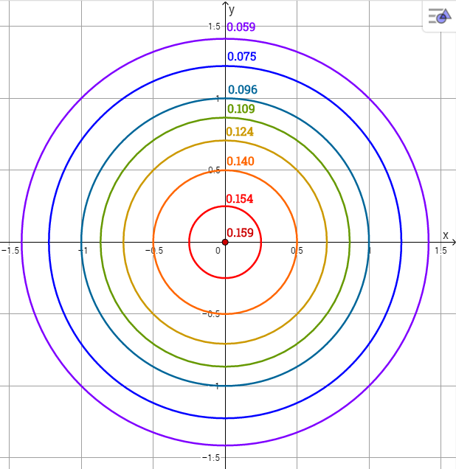

*Made and colored “by hand” in Geogebra app :)